Keeping our people informed

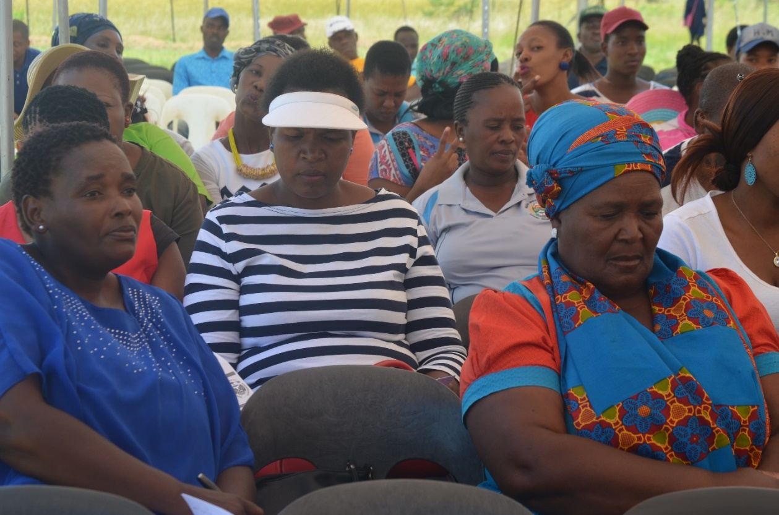
Community members during MPAC Public Hearing held at Ramogwerane

On 1st and 2nd March 2018, Elias Motsoaledi Local Municipality, MPAC Chairperson, Cllr Justice Makunyane , led the Municipal Public accounts Committee (MPAC) on the Draft 2016/2017 annual report Public Hearing to certain areas of the Municipality
The main purpose of the MPAC is to exercise oversight over the executive functionaries of council and to ensure good governance in the municipality and the municipal entity.
The Chairperson tabled the 2016/2017 Municipal annual report to members of the community present. In his presentation Cllr Makunyane stressed the importance of partnerships with business and other key stakeholders so as to develop the Municipal area and its people. He said such partnerships are of great need, specifically for cooperatives and small, medium and micro enterprises in the area to flourish and to be sustainable, thus giving the local economy a boost.
Makunyane also made mention of municipal projects that are at an advanced stage of completion, such as the Kgaphamadi bus road phase 3, Mogaung bus road phase 3 , Kgoshi Rammupudu assess road phase 3, Mathula Bus road phase 2 and the re-gravelling of roads
A number of residents in attendance strongly raised the issue like Free Basic Electricity, Access roads, high mast light, waste, Local Economic development, water and Bursaries.
Cllr Makunyane also encouraged those that are receiving services from the municipality to pay their rates. He said Elias Motsoaledi is a rural municipality by its nature, therefore it is only a limited number of people who are ratepayers. He said when such people are defaulting in payments, and themunicipality struggles in collecting money owed by residents, a dent is then created in the municipal budget and service delivery will be affected.

